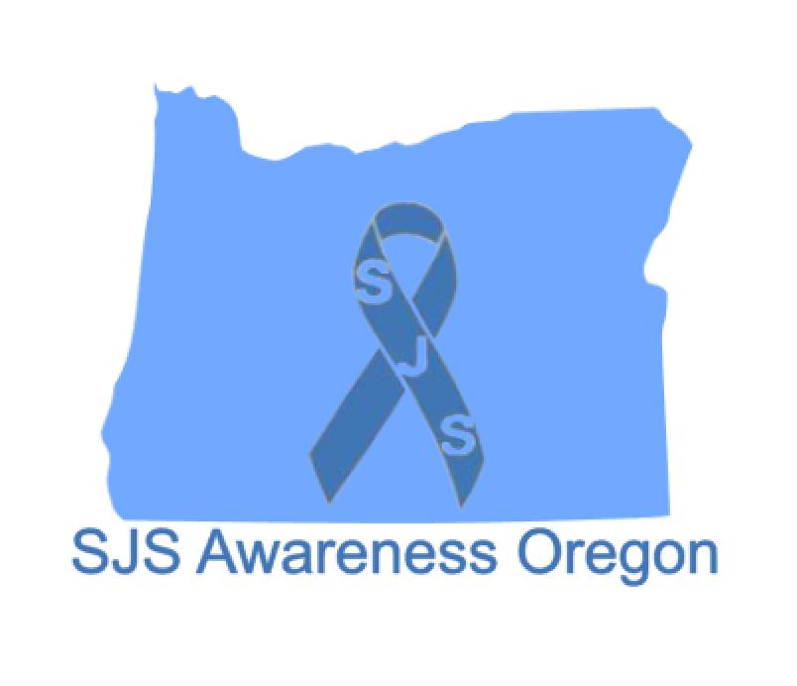
SJS Awareness Oregon – 2026 Fundraising
SJS Awareness Oregon will be postponing our annual banquet until 2027. This change is due to an exciting opportunity: Nicole Chapman has been invited to speak at Vanderbilt University’s Stevens-Johnson Syndrome (SJS) meeting, which falls on the same weekend our banquet was originally scheduled.
At this international gathering, Nicole will share her personal SJS experience with medical professionals and researchers from around the world. She will also connect with other survivors. Her participation will help expand medical awareness of Stevens-Johnson Syndrome, support earlier diagnosis for new patients, and contribute to a better understanding of long-term complications.
Although our banquet is postponed, our mission continues—and we are asking for your support to help sustain our local projects throughout 2026.

Our ongoing projects include:
- Providing SJS medical information packets to healthcare workers
- Awarding two scholarships to Miss Klamath County contestants pursuing medical careers
- Donating toys to the Sky Lakes Medical Center Pediatric Unit
- Supporting and promoting David’s Chair
- Delivering thank-you gifts to healthcare professionals
- And additional community outreach efforts

Sponsorship Options
- $ 200 – Business name displayed on the SJS event trailer
- $______ – Donation in any amount
If you would like to support our work, please contact Chapman at 541-363-2017.
Checks may be made payable to SJS Awareness Oregon. We are a 501(c)(3) organization. Contributions may be tax-deductible; please consult your tax advisor.
If you would like to donate to the fundraiser, please complete the form on other side:

Business Name (as you would like it to appear):
Contact Person:
Address:
Phone:
Email:
Would you prefer to be a silent sponsor? _____ YES _____ NO
(If yes, your name will not be listed on our Facebook page.)

Return to: SJS Awareness Oregon 34112 Ophir rd. Gold beach OR, 97444
www.sjsawarenessoregon.org

